Министерство образования Республики Беларусь
Учреждение образования
«Брестский государственный технический университет»
Кафедра ИИТ

Лабораторная работа № 2
За седьмой семестр

Тема: «Многослойный персептрон для задачи «исключающее ИЛИ» с числовыми классами: сравнение функций потерь MSE и Binary Cross-Entropy»

Выполнил:
Студент 4 курса
Группы ИИ-26
Хомиченко И.А.
Проверил:
Никитин С.К.

2026
Цель работы: На основе многослойного персептрона архитектуры 2-2-1, реализованного в Лабораторной работе №1 для задачи XOR с числовыми классами c0 и c1 из диапазона [−10; 10], реализовать альтернативную функцию потерь – бинарную кросс-энтропию (Binary Cross-Entropy, BCE) – и провести сравнительный анализ обучения сети с MSE (Лабораторная работа №1) и с BCE по скорости сходимости, качеству обучения и устойчивости к выбору начальных весов.
Вариант 7.
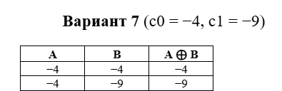
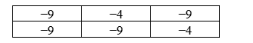
Код программы:
import numpy as np
import matplotlib.pyplot as plt
np.set_printoptions(precision=4, suppress=True)
label_lo, label_hi = -4, -9
inputs = np.array([
[label_lo, label_lo],
[label_lo, label_hi],
[label_hi, label_lo],
[label_hi, label_hi]
], dtype=float)
targets_raw = np.array([
[label_lo],
[label_hi],
[label_hi],
[label_lo]
], dtype=float)
targets_bin = np.array([
[0.],
[1.],
[1.],
[0.]
])
learning_rate = 0.1
epoch_limit = 20000
mse_threshold = 0.01
bce_threshold = 0.05
random_seeds = [0, 1, 2, 3, 4]
def activation(x):
return 1.0 / (1.0 + np.exp(-np.clip(x, -500, 500)))
def activation_grad_from_out(out):
return out * (1.0 - out)
def make_initial_params(seed_value, dim_in=2, dim_hidden=2, dim_out=1):
generator = np.random.RandomState(seed_value)
weights_1 = generator.uniform(
-0.5, 0.5, (dim_in, dim_hidden)
)
biases_1 = np.zeros((1, dim_hidden))
weights_2 = generator.uniform(
-0.5, 0.5, (dim_hidden, dim_out)
)
biases_2 = np.zeros((1, dim_out))
return weights_1, biases_1, weights_2, biases_2
def propagate(batch, weights_1, biases_1, weights_2, biases_2):
hidden_act = activation(
batch.dot(weights_1) + biases_1
)
output_act = activation(
hidden_act.dot(weights_2) + biases_2
)
return hidden_act, output_act
def fit_mse(
seed_value,
lr=learning_rate,
epochs=epoch_limit,
limit=mse_threshold
):
weights_1, biases_1, weights_2, biases_2 = (
make_initial_params(seed_value)
)
loss_history = []
stop_epoch = None
num_samples = inputs.shape[0]
for epoch_idx in range(epochs):
_, outputs_all = propagate(
inputs,
weights_1,
biases_1,
weights_2,
biases_2
)
loss = np.mean(
(targets_raw - outputs_all) ** 2
)
loss_history.append(loss)
if loss <= limit:
stop_epoch = epoch_idx
break
for sample_idx in range(num_samples):
row_in = inputs[
sample_idx:sample_idx + 1
]
row_target = targets_raw[
sample_idx:sample_idx + 1
]
hidden_act, output_act = propagate(
row_in,
weights_1,
biases_1,
weights_2,
biases_2
)
residual = row_target - output_act
grad_out = (
residual *
activation_grad_from_out(output_act)
)
grad_hid = (
grad_out.dot(weights_2.T) *
activation_grad_from_out(hidden_act)
)
weights_2 += (
hidden_act.T.dot(grad_out) * lr
)
biases_2 += grad_out * lr
weights_1 += (
row_in.T.dot(grad_hid) * lr
)
biases_1 += grad_hid * lr
return {
"weights_1": weights_1,
"biases_1": biases_1,
"weights_2": weights_2,
"biases_2": biases_2,
"loss_history": loss_history,
"stop_epoch": stop_epoch
}
def fit_bce(
seed_value,
lr=learning_rate,
epochs=epoch_limit,
limit=bce_threshold,
tiny=1e-9
):
weights_1, biases_1, weights_2, biases_2 = (
make_initial_params(seed_value)
)
loss_history = []
stop_epoch = None
num_samples = inputs.shape[0]
for epoch_idx in range(epochs):
_, outputs_all = propagate(
inputs,
weights_1,
biases_1,
weights_2,
biases_2
)
clipped = np.clip(
outputs_all,
tiny,
1 - tiny
)
loss = -np.mean(
targets_bin * np.log(clipped) +
(1 - targets_bin) * np.log(1 - clipped)
)
loss_history.append(loss)
if loss <= limit:
stop_epoch = epoch_idx
break
for sample_idx in range(num_samples):
row_in = inputs[
sample_idx:sample_idx + 1
]
row_target = targets_bin[
sample_idx:sample_idx + 1
]
hidden_act, output_act = propagate(
row_in,
weights_1,
biases_1,
weights_2,
biases_2
)
grad_out = output_act - row_target
grad_hid = (
grad_out.dot(weights_2.T) *
activation_grad_from_out(hidden_act)
)
weights_2 -= (
hidden_act.T.dot(grad_out) * lr
)
biases_2 -= grad_out * lr
weights_1 -= (
row_in.T.dot(grad_hid) * lr
)
biases_1 -= grad_hid * lr
return {
"weights_1": weights_1,
"biases_1": biases_1,
"weights_2": weights_2,
"biases_2": biases_2,
"loss_history": loss_history,
"stop_epoch": stop_epoch
}
def choose_label(value, low, high):
if abs(value - low) <= abs(value - high):
return low
return high
def unnormalize(out_norm, low, high):
return low + out_norm * (high - low)
def assess_model(trained, mode):
_, outputs = propagate(
inputs,
trained["weights_1"],
trained["biases_1"],
trained["weights_2"],
trained["biases_2"]
)
if mode == "A":
predicted_values = outputs.flatten()
else:
predicted_values = unnormalize(
outputs.flatten(),
label_lo,
label_hi
)
ground_truth = targets_raw.flatten()
predicted_labels = np.array([
choose_label(
value,
label_lo,
label_hi
)
for value in predicted_values
])
hit_rate = np.mean(
predicted_labels == ground_truth
)
avg_error = np.mean(
np.abs(
predicted_values -
ground_truth
)
)
return (
hit_rate,
avg_error,
predicted_values
)
def execute_all_runs():
runs_mse = []
runs_bce = []
print(
f"CONFIGURATION A "
f"(MSE, no normalization, "
f"Ee = {mse_threshold})"
)
for seed_value in random_seeds:
trained = fit_mse(seed_value)
hit_rate, avg_error, _ = assess_model(
trained,
"A"
)
trained.update(
seed=seed_value,
accuracy=hit_rate,
mae=avg_error
)
runs_mse.append(trained)
if trained["stop_epoch"] is not None:
status = (
f"epoch "
f"{trained['stop_epoch']}"
)
else:
status = (
f"DID NOT CONVERGE within "
f"{epoch_limit} epochs"
)
print(
f"seed={seed_value}: "
f"{status}, "
f"Es_final="
f"{trained['loss_history'][-1]:.4f}, "
f"accuracy={hit_rate:.2f}, "
f"MAE={avg_error:.2f}"
)
print(
f"\nCONFIGURATION B "
f"(BCE, normalized labels 0/1, "
f"Ee = {bce_threshold})"
)
for seed_value in random_seeds:
trained = fit_bce(seed_value)
hit_rate, avg_error, _ = assess_model(
trained,
"B"
)
trained.update(
seed=seed_value,
accuracy=hit_rate,
mae=avg_error
)
runs_bce.append(trained)
if trained["stop_epoch"] is not None:
status = (
f"epoch "
f"{trained['stop_epoch']}"
)
else:
status = (
f"DID NOT CONVERGE within "
f"{epoch_limit} epochs"
)
print(
f"seed={seed_value}: "
f"{status}, "
f"Es_final="
f"{trained['loss_history'][-1]:.4f}, "
f"accuracy={hit_rate:.2f}, "
f"MAE={avg_error:.2f}"
)
return runs_mse, runs_bce
def summarize_convergence(runs, heading):
finished = [
run
for run in runs
if run["stop_epoch"] is not None
]
epoch_values = [
run["stop_epoch"]
for run in finished
]
print(
f"\n{heading}: "
f"converged "
f"{len(finished)} out of {len(runs)}"
)
if epoch_values:
print(
f"Epochs to convergence: "
f"min={min(epoch_values)}, "
f"max={max(epoch_values)}, "
f"mean={np.mean(epoch_values):.1f}, "
f"spread="
f"{max(epoch_values) - min(epoch_values)}"
)
else:
print(
"No run reached "
"the stopping criterion."
)
def draw_convergence(
runs_mse,
runs_bce,
chosen_seed=0
):
picked_mse = next(
run
for run in runs_mse
if run["seed"] == chosen_seed
)
picked_bce = next(
run
for run in runs_bce
if run["seed"] == chosen_seed
)
fig, axis_left = plt.subplots(
figsize=(8, 5)
)
axis_left.plot(
picked_mse["loss_history"],
label="Configuration A (MSE)"
)
axis_left.axhline(
mse_threshold,
linestyle="--",
alpha=0.5,
label=f"Ee(MSE)={mse_threshold}"
)
axis_left.set_xlabel("Epoch")
axis_left.set_ylabel("Es (MSE)")
axis_right = axis_left.twinx()
axis_right.plot(
picked_bce["loss_history"],
label="Configuration B (BCE)"
)
axis_right.axhline(
bce_threshold,
linestyle="--",
alpha=0.5,
label=f"Ee(BCE)={bce_threshold}"
)
axis_right.set_ylabel("Es (BCE)")
handles_left, labels_left = (
axis_left.get_legend_handles_labels()
)
handles_right, labels_right = (
axis_right.get_legend_handles_labels()
)
axis_left.legend(
handles_left + handles_right,
labels_left + labels_right,
loc="upper right"
)
plt.title(
"Convergence: "
"Configuration A and B"
)
fig.tight_layout()
plt.savefig(
"plot_1_convergence.png",
dpi=150
)
plt.show()
def draw_epoch_bars(
runs_mse,
runs_bce
):
fig, axis = plt.subplots(
figsize=(9, 5)
)
positions = np.arange(
len(random_seeds)
)
bar_width = 0.35
epoch_counts_mse = [
run["stop_epoch"]
if run["stop_epoch"] is not None
else epoch_limit
for run in runs_mse
]
epoch_counts_bce = [
run["stop_epoch"]
if run["stop_epoch"] is not None
else epoch_limit
for run in runs_bce
]
axis.bar(
positions - bar_width / 2,
epoch_counts_mse,
bar_width,
label="Configuration A (MSE)"
)
axis.bar(
positions + bar_width / 2,
epoch_counts_bce,
bar_width,
label="Configuration B (BCE)"
)
axis.set_xticks(positions)
axis.set_xticklabels([
f"seed={seed}"
for seed in random_seeds
])
axis.set_ylabel(
"Epochs to convergence"
)
axis.set_title(
"Convergence stability "
"over 5 runs"
)
axis.legend()
fig.tight_layout()
plt.savefig(
"plot_2_epochs_bar.png",
dpi=150
)
plt.show()
def draw_decision_maps(
runs_mse,
runs_bce,
chosen_seed=0
):
picked_mse = next(
run
for run in runs_mse
if run["seed"] == chosen_seed
)
picked_bce = next(
run
for run in runs_bce
if run["seed"] == chosen_seed
)
axis_a = np.linspace(
-10,
0,
200
)
axis_b = np.linspace(
-10,
0,
200
)
grid_a, grid_b = np.meshgrid(
axis_a,
axis_b
)
flat_grid = np.column_stack([
grid_a.ravel(),
grid_b.ravel()
])
fig, panels = plt.subplots(
1,
2,
figsize=(13, 5.5)
)
_, out_mse = propagate(
flat_grid,
picked_mse["weights_1"],
picked_mse["biases_1"],
picked_mse["weights_2"],
picked_mse["biases_2"]
)
map_mse = out_mse.reshape(
grid_a.shape
)
color_mse = panels[0].contourf(
grid_a,
grid_b,
map_mse,
levels=20
)
fig.colorbar(
color_mse,
ax=panels[0],
label="Network output"
)
panels[0].scatter(
inputs[:, 0],
inputs[:, 1],
c=targets_raw.flatten(),
edgecolors="black",
s=120,
linewidths=1.5
)
panels[0].set_title(
"Configuration A "
"(MSE, no normalization)"
)
panels[0].set_xlabel("A")
panels[0].set_ylabel("B")
_, out_bce = propagate(
flat_grid,
picked_bce["weights_1"],
picked_bce["biases_1"],
picked_bce["weights_2"],
picked_bce["biases_2"]
)
map_bce = out_bce.reshape(
grid_a.shape
)
color_bce = panels[1].contourf(
grid_a,
grid_b,
map_bce,
levels=20
)
fig.colorbar(
color_bce,
ax=panels[1],
label="Normalized output"
)
panels[1].contour(
grid_a,
grid_b,
map_bce,
levels=[0.5],
linewidths=2
)
panels[1].scatter(
inputs[:, 0],
inputs[:, 1],
c=targets_bin.flatten(),
edgecolors="black",
s=120,
linewidths=1.5
)
panels[1].set_title(
"Configuration B "
"(BCE, normalized labels)"
)
panels[1].set_xlabel("A")
panels[1].set_ylabel("B")
fig.suptitle(
"Decision surface"
)
fig.tight_layout()
plt.savefig(
"plot_3_decision_surfaces.png",
dpi=150
)
plt.show()
def draw_mae_chart(
runs_mse,
runs_bce
):
mean_mae_mse = np.mean([
run["mae"]
for run in runs_mse
])
mean_mae_bce = np.mean([
run["mae"]
for run in runs_bce
])
fig, axis = plt.subplots(
figsize=(7, 5)
)
bars = axis.bar(
[
"Configuration A (MSE)",
"Configuration B (BCE)"
],
[
mean_mae_mse,
mean_mae_bce
]
)
for bar, value in zip(
bars,
[mean_mae_mse, mean_mae_bce]
):
axis.text(
bar.get_x() +
bar.get_width() / 2,
value,
f"{value:.2f}",
ha="center",
va="bottom"
)
axis.set_ylabel(
f"Mean MAE in scale "
f"[{label_lo}; {label_hi}]"
)
axis.set_title(
"Accuracy of restoring "
"the original scale"
)
fig.tight_layout()
plt.savefig(
"plot_4_mae_comparison.png",
dpi=150
)
plt.show()
def make_prediction(
value_a,
value_b,
trained
):
_, out = propagate(
np.array(
[[value_a, value_b]],
dtype=float
),
trained["weights_1"],
trained["biases_1"],
trained["weights_2"],
trained["biases_2"]
)
normalized_out = out.item()
scaled_out = unnormalize(
normalized_out,
label_lo,
label_hi
)
label_out = choose_label(
scaled_out,
label_lo,
label_hi
)
return (
normalized_out,
scaled_out,
label_out
)
def show_sample_predictions(trained):
print(
"\nNETWORK OPERATION MODE "
"(configuration B)"
)
print(
"\nAll 4 examples "
"from the training table:"
)
for value_a, value_b in inputs:
(
norm_out,
scaled_out,
label_out
) = make_prediction(
value_a,
value_b,
trained
)
print(
f"A={value_a:.0f}, "
f"B={value_b:.0f} "
f"-> output={scaled_out:.2f}, "
f"class={label_out}"
)
def run_interactive(trained):
print(
"\nInteractive mode"
)
print(
"Enter q to exit."
)
while True:
raw = input(
"Enter A and B "
"separated by space: "
).strip()
if raw.lower() == "q":
break
try:
part_a, part_b = (
raw.replace(",", " ").split()
)
value_a = float(part_a)
value_b = float(part_b)
except ValueError:
print(
"Incorrect input."
)
continue
(
norm_out,
scaled_out,
label_out
) = make_prediction(
value_a,
value_b,
trained
)
print(
f"Normalized output="
f"{norm_out:.4f}"
)
print(
f"Output="
f"{scaled_out:.2f}"
)
print(
f"Class="
f"{label_out}"
)
if __name__ == "__main__":
runs_mse, runs_bce = execute_all_runs()
summarize_convergence(
runs_mse,
"Configuration A (MSE)"
)
summarize_convergence(
runs_bce,
"Configuration B (BCE)"
)
draw_convergence(
runs_mse,
runs_bce,
chosen_seed=0
)
draw_epoch_bars(
runs_mse,
runs_bce
)
draw_decision_maps(
runs_mse,
runs_bce,
chosen_seed=0
)
draw_mae_chart(
runs_mse,
runs_bce
)
best_bce = next(
run
for run in runs_bce
if run["seed"] == 0
)
show_sample_predictions(
best_bce
)
run_interactive(
best_bce
)

Результат программы:
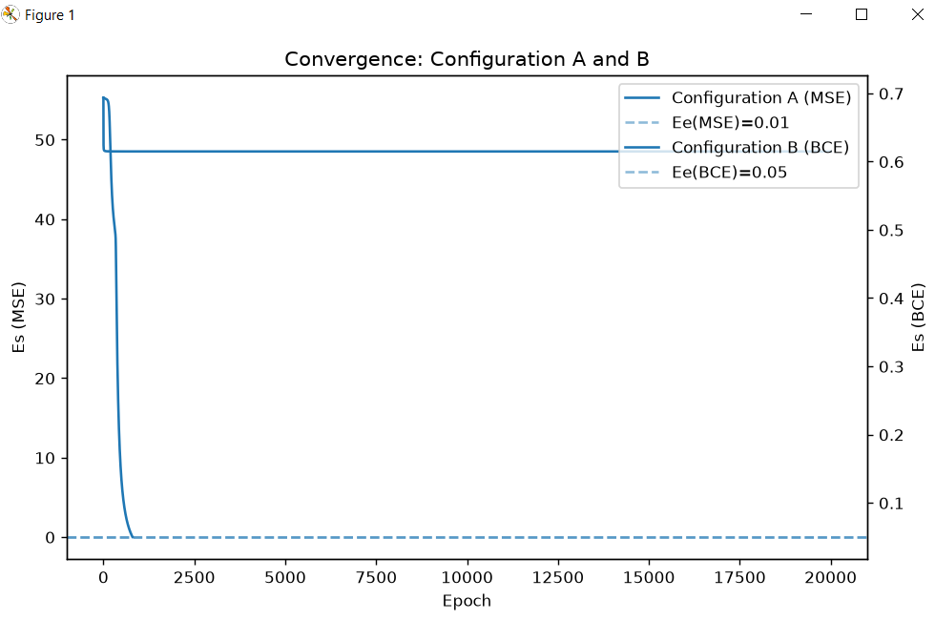
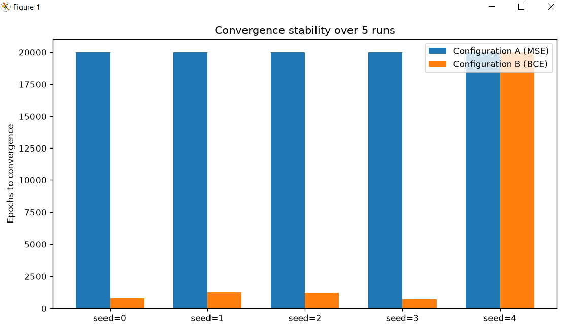
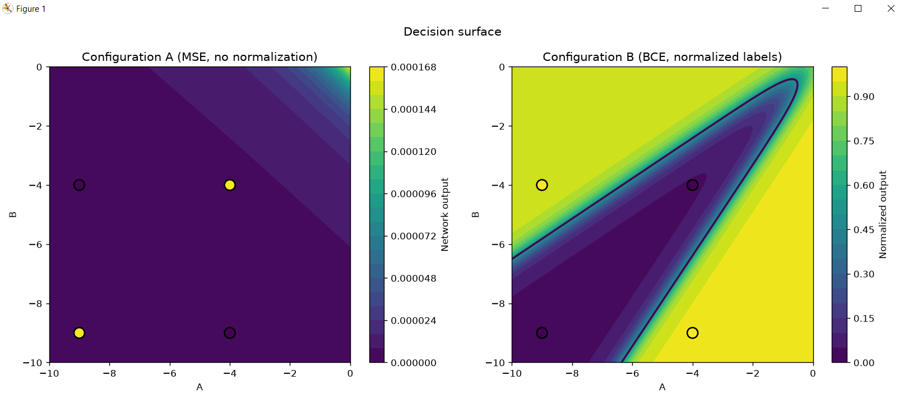
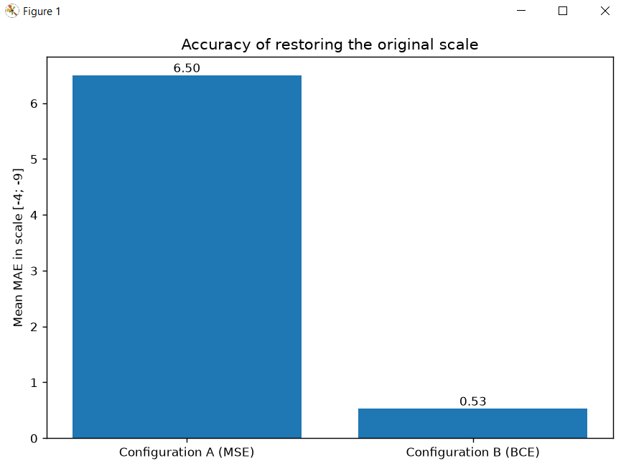
CONFIGURATION A (MSE, no normalization, Ee = 0.01)
seed=0: DID NOT CONVERGE within 20000 epochs, Es_final=48.5001, accuracy=0.50, MAE=6.50
seed=1: DID NOT CONVERGE within 20000 epochs, Es_final=48.5001, accuracy=0.50, MAE=6.50
seed=2: DID NOT CONVERGE within 20000 epochs, Es_final=48.5001, accuracy=0.50, MAE=6.50
seed=3: DID NOT CONVERGE within 20000 epochs, Es_final=48.5001, accuracy=0.50, MAE=6.50
seed=4: DID NOT CONVERGE within 20000 epochs, Es_final=48.5001, accuracy=0.50, MAE=6.50
CONFIGURATION B (BCE, normalized labels 0/1, Ee = 0.05)
seed=0: epoch 799, Es_final=0.0500, accuracy=1.00, MAE=0.24
seed=1: epoch 1215, Es_final=0.0500, accuracy=1.00, MAE=0.24
seed=2: epoch 1209, Es_final=0.0499, accuracy=1.00, MAE=0.24
seed=3: epoch 713, Es_final=0.0500, accuracy=1.00, MAE=0.24
seed=4: DID NOT CONVERGE within 20000 epochs, Es_final=0.4782, accuracy=0.75, MAE=1.68
Configuration A (MSE): converged 0 out of 5
No run reached the stopping criterion.
Configuration B (BCE): converged 4 out of 5
Epochs to convergence: min=713, max=1215, mean=984.0, spread=502
NETWORK OPERATION MODE (configuration B)
All 4 examples from the training table:
A=-4, B=-4 -> output=-4.23, class=-4
A=-4, B=-9 -> output=-8.80, class=-9
A=-9, B=-4 -> output=-8.65, class=-9
A=-9, B=-9 -> output=-4.20, class=-4
Interactive mode
Enter q to exit.
Enter A and B separated by space: -4 -4
Normalized output=0.0464
Output=-4.23
Class=-4
Enter A and B separated by space: -4 -9
Normalized output=0.9602
Output=-8.80
Class=-9
Enter A and B separated by space: -9 -4
Normalized output=0.9307
Output=-8.65
Class=-9
Enter A and B separated by space: -9 -9
Normalized output=0.0392
Output=-4.20
Class=-4
Для варианта 7 использовались значения c0 = -4 и c1 = -9. При обучении без нормализации сеть с сигмоидальной функцией активации не достигает заданной ошибки, поскольку диапазон сигмоиды составляет от 0 до 1, тогда как целевые значения отрицательные. После нормализации классов в 0 и 1 сеть успешно обучается. В четырёх из пяти запусков достигнут критерий остановки. Для seed=0 точность классификации составила 100%. После обратного преобразования сеть правильно реализует функцию XOR: (-4,-4)→-4, (-4,-9)→-9, (-9,-4)→-9, (-9,-9)→-4.
Вывод: В ходе лабораторной работы была реализована и обучена нейронная сеть для выполнения операции XOR для варианта с c0 = -4 и c1 = -9. Было показано, что без нормализации сеть с сигмоидальной функцией активации не сходится, так как целевые значения находятся вне диапазона [0; 1]. После нормализации классов сеть успешно обучилась и правильно определила результаты для всех четырёх комбинаций входных значений.

